STERLING HIGH SCHOOL DISTRICT
501 S. WARWICK ROAD, SOMERDALE, NEW JERSEY 08083-2175
PHONE (856) 784-1287 FAX (856) 784-7823

Matthew Sheehan
Superintendent
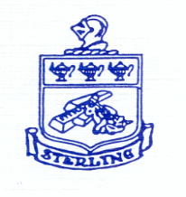

Student Government
10-2-23

Student agenda:
- Female products
  - Free products
  - Locker room was updated
  - Something of a bill https://pub.njleg.state.nj.us/Bills/2022/A1500/1349_R1.PDF
    - Required half the
- Prep of pep rally
  - New games
- BIU meeting
  - Calculating points

Agenda:
- Showcase Night support
- Off campus
  - Highland
  - Haddonfield
  - Paulsboro
  - Admin to rech out to schools for info
- Mr. D. inquired on how students define BIU
  - Inquired on goals and how he can best support and recognize small wins with students.
Subject | Off-Campus Lunch Proposal
From | Ayanna Brown
To | Jarod Claybourn
Cc | Helena Walsh; Cassidy Sweeney; Jordan Baker; Brian Mclernon; Alea Herman; Lana Croce
Sent | Wednesday, July 19, 2023 10:44 AM
Attachments | <<lunch proposal.docx>>

Goodmorning and we hope that when you get a chance you look and consider our proposal for having off campus lunch for the following school year. Thank you and we hope to hear from you soon.
Sincerely,
Senior Class Officers
Get Outlook for iOS

