STERLING HIGH SCHOOL DISTRICT
501 S. WARWICK ROAD, SOMERDALE, NEW JERSEY 08083-2175
PHONE (856) 784-1287 FAX (856) 784-7823

Matthew Sheehan
Superintendent
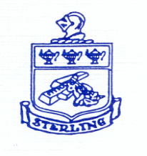

STERLING REGIONAL HIGH SCHOOL DISTRICT
COMMUNITY ADVOCACY GROUP
DECEMBER 4, 2023

AGENDA

- Welcome and Introductions
- Attendees: Denise Sellers, Chrissy Rivera, Rachel Hample, Rick Krause, Julie Crawford, Stacy Baker, Colm Fidgeon, Anita Schwartz, Mary Lomax, Emily Balog, Monica Boggan
  - Notified of missing: Mike Sheridan, Jim Randazzo
- Review Year One Action Plan
  - School Programs & Instruction
    - Academic Schedule
    - Academic Rigor
    - Expansion of Trade and Career Opportunities
  - School Environment
    - Transformative Student Voice
    - Teacher and Staff Leadership
    - Community Voice
  - School and Community Partners
    - Service to Community
    - Program and Curriculum Alignment
    - Feasibility of Single PK-12 District
  - Regionalization Update
    - Rowan University School Regionalization Institute
    - LEAP Grant Award
    - Feasibility and Shared Services Study
- Group Activity
  - Goals of Study
  - Questions / Challenges to Regionalization
  - Possible Solutions

Challenges to the Feasibility Study and Regionalization

