STERLING HIGH SCHOOL DISTRICT

501 S. WARWICK ROAD, SOMERDALE, NEW JERSEY 08083-2175

PHONE (856) 784-1287 FAX (856) 784-7823

Matthew Sheehan  
Superintendent

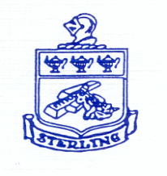

Academic Rigor Table of Contents

1. 9-5-24 BOE Meeting: Approval of Grading Committee
2. 10-17-24 BOE Meeting: Approval of Staff
3. 10-29-24 Kick Off Grading Committee Meeting
4. 10-23-24 Policy 2624 Grading System Review
5. 12-4-24 Grading Committee Meeting #2 Review Policy 2624
6. 12-4-24 Advantages / Disadvantages 10 Point Scale
7. 12-5-24 Grading Scale Comparisons
8. 12-12-24 Grading Committee Proposed Grading Scale
9. 4-3-25 Education Committee Meeting Recommendation