STERLING HIGH SCHOOL DISTRICT

501 S. WARWICK ROAD, SOMERDALE, NEW JERSEY 08083-2175

PHONE (856) 784-1287 FAX (856) 784-7823

Matthew Sheehan  
Superintendent

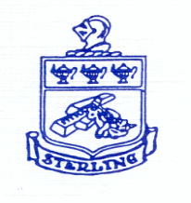

3-10-25 Site Visit Update

Good afternoon,

Mr. Sheehan I can reschedule your full QSAC on site visit for Thursday, May 22nd.  Thank you.

Cindy S. Mc Coy, BA

Administrative Assistant

Camden County Office of Education

420 Woodbury-Turnersville Road

Blackwood, NJ 08012

Email: [cindy.mccoy@doe.nj.gov](mailto:cindy.mccoy@doe.nj.gov)

Phone:(856) 401-2400 Ext. 42404

Fax: (856) 401-2410