STERLING HIGH SCHOOL DISTRICT

501 S. WARWICK ROAD, SOMERDALE, NEW JERSEY 08083-2175

PHONE (856) 784-1287 FAX (856) 784-7823

Matthew Sheehan  
Superintendent

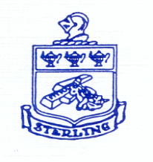

12-2-24 NJQSAC Declaration Page

Approve the following resolution for review/submission of the New Jersey Quality Single Accountability Continuum (QSAC) District Performance Review Tally Sheets for the 2024-2025 School Year.

NOW THEREFORE, BE IT RESOLVED by the Board of Education of Sterling High School District as follows:

The Sterling Board of Education hereby certifies that all responses contained in the NJ Quality Single Accountability Continuum (NJQSAC) District Performance Review Tally Sheets – School Year 2024-2025 have been reviewed by the Board of Education for accuracy and approve the file for submission to the New Jersey Department of Education.

