STERLING HIGH SCHOOL DISTRICT

501 S. WARWICK ROAD, SOMERDALE, NEW JERSEY 08083-2175

PHONE (856) 784-1287 FAX (856) 784-7823

Matthew Sheehan  
Superintendent

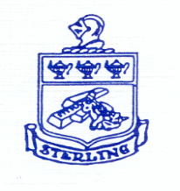

10-16-24 QSAC Training

Good Morning,

This is a reminder that today is the QSAC Training Virtual Meeting with Camden County.  Please feel free to log in and out as needed, based upon the topics relevant to your area.  The schedule is as follows:

1. Governance: 9:30 am - 10:00 am
2. Operations: 10:00 am-10:30 am
3. Instruction and Program: 10:30am-11:00am
4. Personnel: 11:00 am-11:30am

Additionally, we are postponing the DPR review to the week of October 28th.  I will send out a meeting invitation with the details closer to the date.

Thanks