STERLING HIGH SCHOOL DISTRICT

501 S. WARWICK ROAD, SOMERDALE, NEW JERSEY 08083-2175

PHONE (856) 784-1287 FAX (856) 784-7823

Matthew Sheehan  
Superintendent

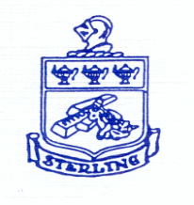

Superintendent Goal #4: Special Education Parent Advisory Committee (SEPAC)

