STERLING HIGH SCHOOL DISTRICT
501 S. WARWICK ROAD, SOMERDALE, NEW JERSEY 08083-2175
PHONE (856) 784-1287 FAX (856) 784-7823

Matthew Sheehan
Superintendent
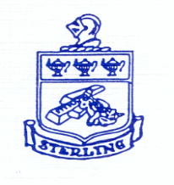

Student Government
2-2-24

Mrs. B, and Mrs. Johnson
Jarod and Frank

SGA items Agenda:
- Senior leaving for lunch
- Student Faculty Bball
  - Possible Tues March 19th
    - 7:30
- Vtines day
  - Free hearts
- ASL club, and add full class

Subject | Fw: Abigail Hyndman shared "Why ASL Should be Taught as a Language Class" with you
From | Kelly Johnson
To | Jarod Claybourn
Cc | Frank DErrico
Sent | Friday, February 2, 2024 10:35 AM

From: Abigail Hyndman <abigailhyndman@sterlingknights.net>
Sent: Friday, February 2, 2024 10:03 AM
To: Kelly Johnson <kjohnson@sterling.k12.nj.us>
Subject: Abigail Hyndman shared "Why ASL Should be Taught as a Language Class" with you

Abigail Hyndman shared a file with you
Here's the document that Abigail Hyndman shared with you.
Why ASL Should be Taught as a Language Class
2 min to read this.

This link will work for anyone.
Open
Privacy Statement

