STERLING HIGH SCHOOL DISTRICT
501 S. WARWICK ROAD, SOMERDALE, NEW JERSEY 08083-2175
PHONE (856) 784-1287 FAX (856) 784-7823

Matthew Sheehan
Superintendent
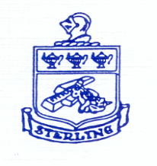

Superintendent Goal #2

Education Committee Meeting
Date: November 3, 2022
Start Time: 6:15
Meeting End Time: 6:55
Attendees: Jason Clark, Emily Reich, Bill Hiltner, Jarod Claybourn, Jim McCullough, Robynn Considine, and Matthew Sheehan

Education Committee Meeting Agenda

- Education / Curriculum / Guidance
  - Start Strong
    - S1 week of 9/26
    - S2 week of 10/3
  - LinkIt
    - Benchmark A completed
      - Data reviews with English/Math depts. during Oct PLC
  - PSAT- October 12th
  - SATs- Sat. 11/5
  - 21-22 NJSLA Results
  - CCC Trade and Technical Programs- Friday, October 21st @ 9:30 (Strategic Goal 1.3.2)
  - Choice 45 Applicants + 8 Incomplete for 32 Open Seats

