STERLING HIGH SCHOOL DISTRICT
501 S. WARWICK ROAD, SOMERDALE, NEW JERSEY 08083-2175
PHONE (856) 784-1287 FAX (856) 784-7823

Matthew Sheehan
Superintendent
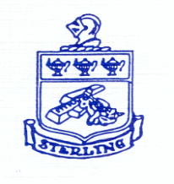

Superintendent Goal #2
September 2, 2022

10/5 PLC | Dept. art project  Finalize SGOs  LinkIt! Benchmark Data Review (English)  PSAT training (proctor assignments attached) | 7:30-8:40  PSAT 8/9 Proctors 7:45-8:00  PSAT NMSQT Proctors 8:15-8:30 | Rm 200  MC Presentation Room  MC Presentation Room
PM 10/7 | Dept. art project  Finalize SGOs  Finalize Mini 8-1 Grades/Comments (due by 2:30)  Equity  Class Advisors  Teacher Leaders | 1:00-2:00  1:00-2:00  2:00-3:00 | Room 405  MC Conference Room  MC Conference Room
PM 10/12 | Dept. art project  Finalize SGOs  Final Exam review within department  ELL support (teachers of ELL students)  IE teachers and aides | 1:00-2:30  1:00-2:30 | Media Center  Old Gym
10/19 PLC | Dept. art project  Final Exam review within department  LinkIt! Benchmark Data Review (Math) | 7:30-8:40 | Room 301

