STERLING HIGH SCHOOL DISTRICT

501 S. WARWICK ROAD, SOMERDALE, NEW JERSEY 08083-2175

PHONE (856) 784-1287 FAX (856) 784-7823

Matthew Sheehan  
Superintendent

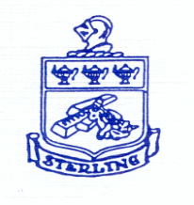

Academic Rigor Grading Committee BOE Approval

Approve establishing three committees for the 2024-2025 school year exploring Restorative Practices as related to student Discipline, Cell Phone Use and School Procedures, and Academic Grading. Each committee will have 6 persons (1 admin and 5 staff) paid at the non-instructional rate of $35 per hour. Approximately 7 hours per person. Total funds not to exceed $4480 from ESEA Title 2 funds for Professional Development.