STERLING HIGH SCHOOL DISTRICT

501 S. WARWICK ROAD, SOMERDALE, NEW JERSEY 08083-2175

PHONE (856) 784-1287 FAX (856) 784-7823

Matthew Sheehan  
Superintendent

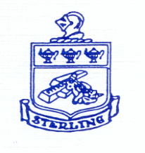

12-12-24 Proposed Grading Scale

|  |  |
| --- | --- |
| A | 90-100 |
| B | 80-89 |
| C | 70-79 |
| D | 60-69 |
| F | <60 |

* Really increases bottom number
* Allows for increased rigor, knowing there is more room for mistakes
* Mental Health

Report Cards include number grade and letter grade

Transcripts include number and letter grade, as well as Weighted GPA/year and Cumulative Weighted GPA

Cumulative Weighted GPA?

Remain unchanged

Good with weights? 8 points? 10 points?

County Directors- questionnaire

Graduation Recognition?

Culture- we don't say one student gets a 100, the next best can only get a 99

Set expectations, not pitting one against the other

Rolling grades

No marking period; not capturing at marking period limits